**Instructions to install & run the KBAToolsLocal toolbox**

# Toolbox Installation:

## How to install the KBAToolsLocal Toolbox:

1. Access & download the **zip file** containing the ArcGIS Pro Python Toolbox from [GitHub](https://github.com/msouthee/kba-tools-local/releases). Click on **Source Code (zip)** in the Assets section of the current release.
2. Unzip the folder somewhere on the computer.
3. In ArcGISPro, add the toolbox to your Project.
   1. In the Catalog Pane, right-click on Toolboxes > Add Toolbox. Navigate to the folder where you unzipped to the files and you should see the toolbox.

Note: You only need to add the toolbox to your Project once. When you save the Project, it will keep the KBAToolsLocal Toolbox loaded in your Project.

# Tool Dependencies & Requirements:

## Requirement 1: Tables and Data Layers

The tools in the toolbox are dependant on 3 tables, 1 group layer and 4 data layers that exist in the original WCSC-KBA Map File.  If any of these tables or layers are missing in your map, or if the have been renamed, then the tool will fail.

* Note: You will get custom error messages if any of these data layers or tables are missing that will help you to troubleshoot these errors.

The graphic below shows the list of tables and data layers that the tools require to run successfully.

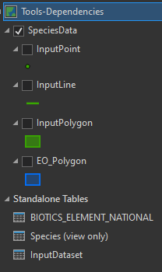

Figure 1: Required data layers and tables

## Requirement 2: Custom Symbology

The tools also need a custom **Style** (i.e. symbology) added to the project, which can be added from **Portal**. The **WCSC-KBA-Symbology** is required to create the output symbology for the range map and critical habitat layers (i.e., ECCCRangeMaps, ECCCCriticalHabitat, IUCNRangeMaps) that are added to the map during tool execution.

The graphic below shows where you can find the **WCSC-KBA-Symbology** layer in Portal.

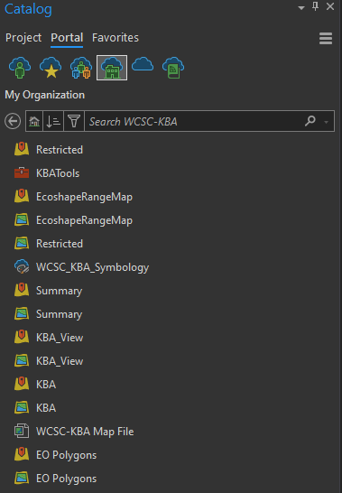

Figure 2: Location of custom style in Portal

## How to add the WCS_KBA_Symbology from Portal:

1. In the **Catalog Pane**, click on **Portal**.
2. Click on the icon for **My Organization** (looks like an office building in a cloud).
3. In My Organization, click on **Groups** (located on the right hand side) to see the groups that you are a part of. Then click on the **WCSC-KBA** group.
4. In the WCSC-KBA group, right click on **WCSC_KBA_Symbology**, then click **Add Style**.

Note: You only need to add the Web Style to the Project once. When you save the Project, it will keep the Style added to your Project.

## How to check that the WCSC_KBA_Symbology Style is loaded:

1. In the **Catalog Pane**, click on **Projects**.
2. Expand the **Styles** section (by clicking on it).
3. Check that the WCSC_KBA_Symbology is in the Styles list.

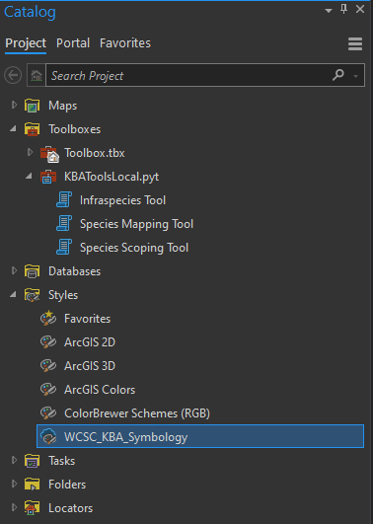

Figure 3: Location of custom Style after you have added it to your project

# Tool Execution:

## How to run the tools:

1. Open the KBAToolsLocal toolbox and run the tool(s) from your project.

## Tips & Recommendations:

1. It **is strongly recommended** that you run the tools in a clean copy of the WCSC-KBA map, so that the tools can find the required data layers and tables. This will minimize the number of errors you encounter during tool execution.
   1. The **WCSC-KBA Map File** can be added to your project from the portal (see figure 2 for a screen grab of where it is located in Portal).
   2. You can refresh the WCSC-KBA map back to its original state in the **Maps** section of the Catalog. Right-click on the WCSC-KBA map, then click **Update**.
      1. DO NOT perform this action on your working map as it will reset it back to the default state where it does not have any definition queries set and it will remove any contextual layers that you have added.
2. You can copy & paste the output results from the Contents pane in your 'tool execution map' into other working maps that you use for KBA delineations and/or workshops.
3. The tools will mimic the display of the SpeciesData group layer, i.e., if you have the SpeciesData group layer expanded the output group layer(s) will also be expanded.